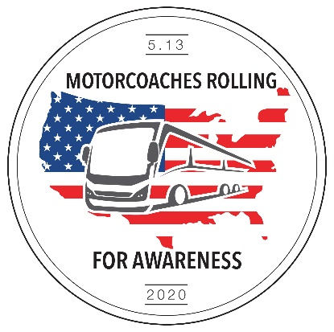

Hello fellow operators.

We are almost there, this once in a lifetime movement is just days away. I apologize for the delay in information and changes as this event has grown. The event has grown in such a way that I never expected and we have had to grow and make changes to make this event go as smooth as possible. When the Idea of a rally was though up I was hopping to get 100 -150 buses to come. I never in a million years thought that all the operators would join together and come. Then Roman Cornell came into play and brought ABC-Companies along with the other manufacturers and turned this into an industry rally. After a few meetings the rally began to grow and become more of an industry movement. Then with the help of ABA and UMA, MR4A took on a life of its own. Now we have 50 states and 25 associations represented and over 450 companies bringing their coaches to DC. This brings tears to my eyes to think that during this pandemic and in the face of extinction, we as an industry have muscled up and come together for this stand. I know that I am proud of the industry and after May 13, 2020 I will be able to hold my head up high and say I was there! I am an operator, MR4A!

Now let’s clear up some questions that have come up in the last 3 days. Below you will see maps and what they are exactly for (the full map pdf is attached). How to get to the rally, what we are going to do at the rally, and how to communicate during the rally. Please make sure that all Drivers are aware of the code of conduct. NO HORNS. If you are going to be coming in separate or have friends or family coming to see the rally, note your bus CAN NOT stop and pick you or them up and then get going again. Once the bus is in the loop it stays in the loop or exits with no return!

Lastly if you have not emailed [Operators@motorcoachesrollingforawareness.com](mailto:Operators@motorcoachesrollingforawareness.com) your:

Company name:

Company contact cell:

Owners name:

Email:

Number of buses you are sending:

Driver of the bus(s) name:

Driver cell:

Please do so today as we are putting together a texting portal to be able to text all drivers and owner’s day of the event.

STAGING AREAS 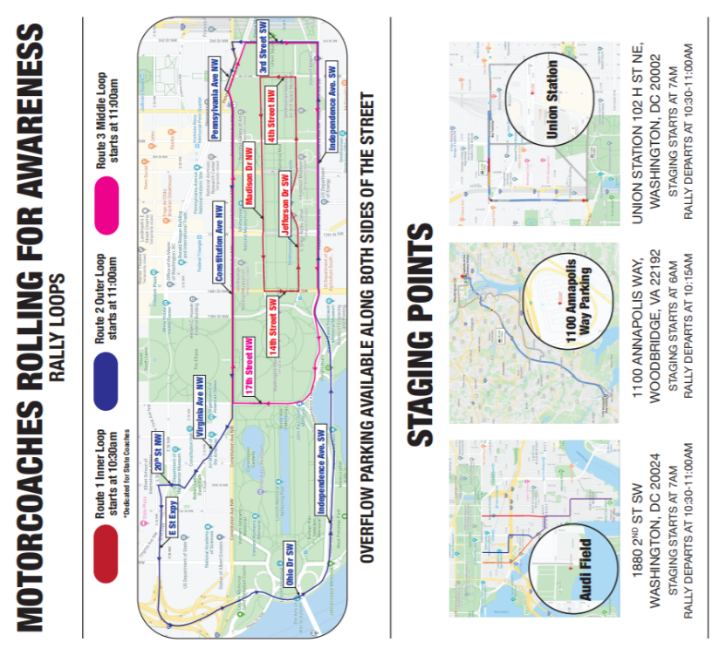

Staging yards are as follows:

The buses with state messages (assigned)

go to **1100 Annapolis Way**, Woodbridge,

VA 22192 between 6:00am and 7:00am

Then 1 bus from each company (unless it is a

previously identified donor bus) will begin

staging from 7:00 am –10:15am behind state

buses. All additional buses that companies wish to send will be directed to:

**Audi Field**

1880 2nd ST SW, Washington DC 20024

PARKING DURING RALLY

If your bus will not be traveling on any of the loops, and you wish to park alongside the loops (parade Routes) please send your bus to: **Union Station**:

102 H ST NE, Washington DC 20002 between 7:am- 11:00am the will be released once the loops begin.

RALLY LOOPS

 *Maps will be given on site.

Link Attached: <https://www.buses.org/assets/images/uploads/pdf/DC_MR4A_Map_5-8.pdf>

Route 1:

This is the inner most loop, this will be where

the manufacturers and the state buses will

run. There is parking alongside this loop

Note, all parking buses first stage at Union Station

RALLY LOOPS (Continued)

Route 2:

This loop will be coming from staging on

1100 Annapolis Way, Woodbridge,

VA 22192. The buses coming from this staging

point will follow the state buses into the city

and will break off after the state buses start

Into the inner loop (route 1). *see map.



Route 3:

This is the Middle route and will be dispatched

from Audi field. This is for any extra buses from

companies and overflow buses from 1100 Annapolis Way

Note, if your buses are separated into different staging

areas, THEY WILL STILL BE ABLE TO PARTICIPATE from

their staging area

There will be food and drinks available for sale at all staging yards (note, not affiliated with the event).

If you are traveling through the night and not planning on getting a hotel locally, there are Points of contact that groups have made. I can share with all if anyone would like to meet up with anyone on the way. I will be sharing POC routes on Sunday afternoon.